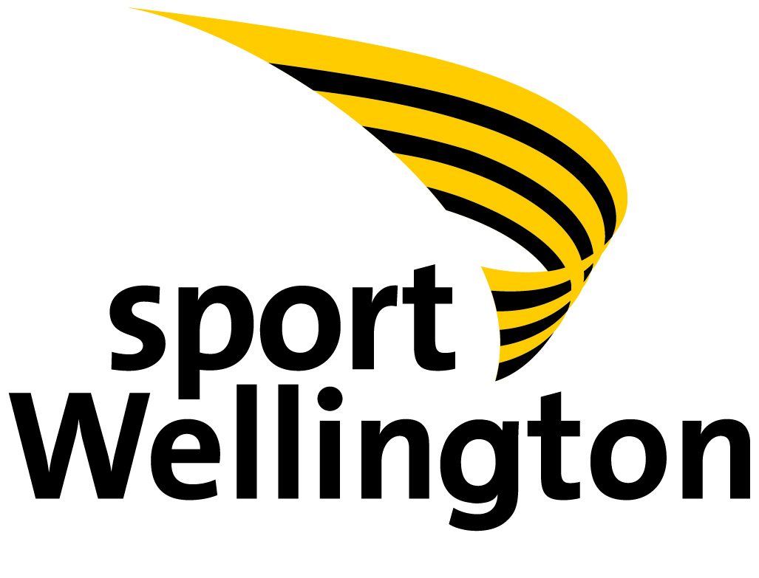

Memorandum of Understanding between Sport Wellington and Wellington United AFC
September 12th 2013 – June 30th 2014

Overview of Memorandum
Sport Wellington
Sport Wellington is a regional sports trust servicing the Greater Wellington Region with the purpose to promote and support sport and recreation in our region
Our Vision: Everyone, everyday experiencing the force of sport and physical recreation
Our Purpose: To promote and support the delivery of sport and recreation
Our Values: Service, Passion, Openness, Respect and Teamwork
Our Strategic Outcomes:
- More kids with a lifelong love of sport and recreation
- Great delivery of and access to sport and recreation
- Strong partners who consistently deliver
Our Priorities:
1: High Performing Sport and Recreation Organisations: Sport Wellington and targeted organisations to be sustainable and capable
2: Facilities and Resources: Promoting the provision of adequate facilities, funding and other resources
3: Inspiring Young People: Excellent sport and recreation experiences for young people including the development of fundamental movement and sport skills
4: Valuing Volunteers: Strong support structures for coaches, officials, administrators and other volunteers to increase capability and participation
5: Playground to Podium: Everyone has the opportunity to reach their personal goals within the sport and recreation environment
Sport Wellington is a partner with Sport New Zealand in supporting New Zealand Football. The agreement with Sport New Zealand is part of the consolidated investment approach to benefit the growth of sport and recreation in the greater Wellington region, in this case, particularly for football
Agreement: dated this 12th day of September 2013
Parties:
The parties to this Memorandum of Understanding (MoU) are:
1) Sport Wellington, and
2) Wellington United AFC
Purpose:
This MoU is tangible acknowledgement that Sport Wellington and Wellington United AFC:

- Recognise they work towards mutually beneficial outcomes, and
- Wish to work together for success in a mutually beneficial manner that enhances each other’s contribution to those outcomes.
There is to be a sense of shared purpose founded in quality relationships and open communication to help ensure that the activities of the parties are aligned and mutually reinforcing

Project:

This project is about increasing the capability, capacity and sustainability of Wellington United AFC in the community it serves
Primarily this will be achieved through Sport Wellington assisting Wellington United AFC with the implementation of NZ Football Quality Club Mark 1 star developing club status and the implementation of a Wellington United AFC plan; refer to matrix
Roles:
Sport Wellington and Wellington United AFC are committed to sharing relevant information and resources. The parties are also committed to mutually supporting each other’s key strategies and programmes where synergies occur

Sport Wellington shall:

1. Provide support, advice, encouragement and mentoring in helping Wellington United AFC achieve the objectives of achieving NZF QCM 1 star and the development and implementation of a Club Plan
2. Provide and share sport best practice examples, templates, toolkits, evaluative and benchmarking tools as are appropriate to the project
3. Utilise its knowledge, experience, skills and relationships to ensure the experience of the Wellington United AFC (volunteer) committee is a positive one
4. Make (at least) monthly contact with Wellington United AFC to ensure the Club is on track to achieving the agreed KPIs; refer to matrix

Wellington United AFC shall:

a. Proactively work towards achieving the agreed KPIs; refer to matrix
b. Complete a Sport New Zealand ‘Club Warrant of Fitness’ and share findings with Sport Wellington
c. Provide base data and forward membership returns and complete surveys as may be required from time to time
d. Provide the latest set of financial accounts
e. Encourage committee attendance at Sport Wellington courses and workshops
f. Forward Sport Wellington’s newsletter – “Sport Connector” to the committee and Club members
g. Acknowledge Sport Wellington as a stakeholder/partner and show links to Sport Wellington website
h. Nominate people for Sport Wellington’s Logan Brown Volunteer of the Month and Logan Brown Coach of the Month awards
i. Promote the Sport Wellington Round the Bays event among its members
j. Promote the Sport Wellington Sportsperson of the Year Awards
k. Keep Sport Wellington fully informed of any circumstances/changes that may impact on the project
l. Keep Sport Wellington informed of meeting dates and personnel changes on the Club committee
m. Keep Capital Football informed on progress

Agreement:
Sport Wellington and Wellington United AFC have a shared commitment to this MoU
Sport Wellington reserves the right to use the best practice models, methodology and learning from this project to assist other sports
Sport Wellington and Wellington United AFC obtain endorsement from Capital Football

Variation:

This MoU shall not be modified unless agreed upon by the listed representatives of both parties. Any modification to this agreement must be signed and authorised by the Sport Development Manager of Sport Wellington, and the President of Wellington United AFC

Effective Date:
This MoU takes effect Thursday 12th September 2013 and will run for one year to Monday June 30th 2014 unless terminated earlier by either the President of Wellington United AFC or the Sport Development Manager of Sport Wellington
This MoU shall be reviewed annually or at such other time as may be agreed by either party

Signatories:

…………………………………………… Signed on …………………………...
(Signature)
(insert name)
President, Wellington United AFC

……………………………………………. Signed on …………………………….
(Signature)
Kevin Wilson
Sport Development Manager, Sport Wellington

……………………………………………. Signed on …………………………….
(Signature)
Richard Reid
CEO, Capital Football
Wellington United AFC  Strategy | ACTION PLAN - Matrix  Sport Wellington (SW) Alignment | Sport Wellington Action | KPI
Increased Club Capability, Capacity and Sustainability  - Accreditation in NZ Football Quality Club Mark 1 Star Developing Club status  - Development and Implementation of 3-5 year Club Plan – if required | 2013-2014  Targeted organisations to be capable and sustainable  Strong support structures for players, coaches, officials, administrators and other volunteers to increase capability and participation | 2013-2014  SW to work alongside Wgtn Utd AFC to support club complete NZ Football QCM 1 star  SW to lead and mentor Club committee in development and implementation of a Club Plan | 2013-2014  QCM accreditation achieved, NZF presentation  Club Plan implemented

